
Booklet


CHEMISTRY 3AB

MULTIPLE CHOICE QUESTIONS BOOKLET

Time allowed for this paper
Reading time before commencing work: ten (10) minutes
Working time for paper: three (3) hours

Materials required/recommended for this paper
To be provided by the supervisor
Booklet 1 – Multiple choice questions booklet
Booklet 2 - Question/Answer booklet with multiple choice answer sheet.
Chemistry Data sheet

To be provided by the candidate
Standard items: pens, pencils, eraser, correction fluid/tape, ruler, highlighters
Special items: non-programmable calculators satisfying the conditions set by the School Curriculum and Standards Authority for this course

Important note to candidates
No other items may be taken into the examination room. It is your responsibility to ensure that you do not have any unauthorised notes or other items of a non-personal nature in the examination room. If you have any unauthorised material with you, hand it to the supervisor before reading any further.

Structure of this paper

Section | Number of questions available |  | Number of questions to  be answered | Suggested  working time  (minutes) |  | Marks  Available | Percentage  of exam
Section One:  Multiple-choice | 25 |  | 25 | 30 |  | 50 | 25
Section Two:  Short answer | 10 |  | 10 | 70 |  | 70 | 35
Section Three:  Extended answer | 4 |  | 4 | 80 |  | 80 | 40
 |  |  |  | Total | 200 |  | 100

Instructions to candidates

1. Write your name and your teacher’s name on Booklet 2 only.

2. The rules for the conduct of Western Australian external examinations are detailed in the Student Information Handbook 2013. Sitting this examination implies that you agree to abide by these rules.

3. Answer the questions according to the following instructions.

Section One: Answer all questions on the Multiple-choice answer sheet attached to the front of Booklet 2. Marks will not be deducted for incorrect answers. No marks will be given if more than one answer is completed for any question.

Sections Two and Three: Write your answers in Booklet 2.

4. When calculating numerical answers, show your working or reasoning clearly unless instructed otherwise.

5. You must be careful to confine your responses to the specific questions asked and to follow any instructions that are specific to a particular question.

6. Spare pages are included at the end of Booklet 2. They can be used for planning your responses and/or as additional space if required to continue an answer.
- Planning: If you use the spare pages in planning, indicate this clearly at the top of the page.
- Continuing an answer: If you need to use the space to continue an answer, indicate in the original answer space where the answer is continued, i.e. give the page number.
Fill in the number of question(s) that you are continuing to answer at the top of the page.

Section One: Multiple-choice 25% (50 marks)
This section has 25 questions. Answer all questions on the separate Multiple-choice Answer Sheet provided. For each question, shade the box to indicate your answer. Use only a blue or black pen to shade the boxes. If you make a mistake, place a cross through that square, then shade your new answer. Do not erase or use correction fluid/tape. Marks will not be deducted for incorrect answers. No marks will be given if more than one answer is completed for any question.
Suggested working time: 30 minutes. _____________________________________________________________________________________________________________________
1. What is the number of protons, electrons and neutrons in the Br ⁵⁺ ion?
81
35
(a) 35 protons 40 electrons 46 neutrons
(b) 35 protons 30 electrons 46 neutrons
(c) 35 protons 30 electrons 81 neutrons
(d) 35 protons 40 electrons 81 neutrons

2. The horizontal axis of the bar chart below represents the elements of period 3 from sodium to chlorine (excluding silicon). What could the vertical axis represent?
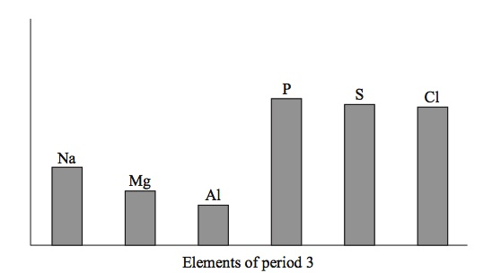
- Melting point of the element

- Electronegativity of the bonded atom

- Ionic radius of the most common ion

- First ionization energy in the gaseous state

3. Which of the following covalent bonds would be expected to have the greatest polarity?
(a) N – F
(b) P – F
(c) S – F
(d) O – F

Questions 4 and 5 are based upon the table below, which gives the first eight ionisation energies
(in kJ mol⁻¹) of four elements, all of which are in the first 20 elements of the Periodic Table.

Element | 1st | 2nd | 3rd | 4th | 5th | 6th | 7th | 8th
(i) | 590 | 1,145 | 4,912 | 6,491 | 8,153 | 10,496 | 12,270 | 14,206
(ii) | 577 | 1,820 | 2,740 | 11,600 | 14,800 | 18,400 | 22,400 | 27,500
(iii) | 495 | 4,562 | 6,910 | 9,543 | 13,354 | 16613 | 20,117 | 25,496
(iv) | 1000 | 2260 | 3390 | 4560 | 6990 | 8490 | 27,200 | 37,100
4. Which element would you expect to have the highest melting point?
- (i)
(b) (ii)
(c) (iii)
(d) (iv)

5. Which element would you expect to have the lowest electronegativity?
- (i)
(b) (ii)
(c) (iii)
(d) (iv)

6. Which of the following structural features is common to both diamond and graphite?
- Covalent bonds between carbon atoms
(b) Delocalised electrons
(c) Dipole-dipole interaction
(d) Covalent dipole attraction

7. Which of the following properties do not have an increasing trend across Period 3 of the Periodic Table?

- Atomic number
(ii) Atomic radius
- Electronegativity
- Ionization energy
- Number of electron shells

(a) (i) and (iv)
(b) (i), (iii) and (iv)
(c) (ii) and (v)
(d) (i), (iii), (iv) and (v)

8. In which of the following liquids would you expect hydrogen bonding to be present between their molecules
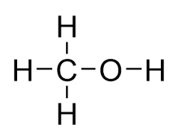
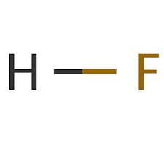
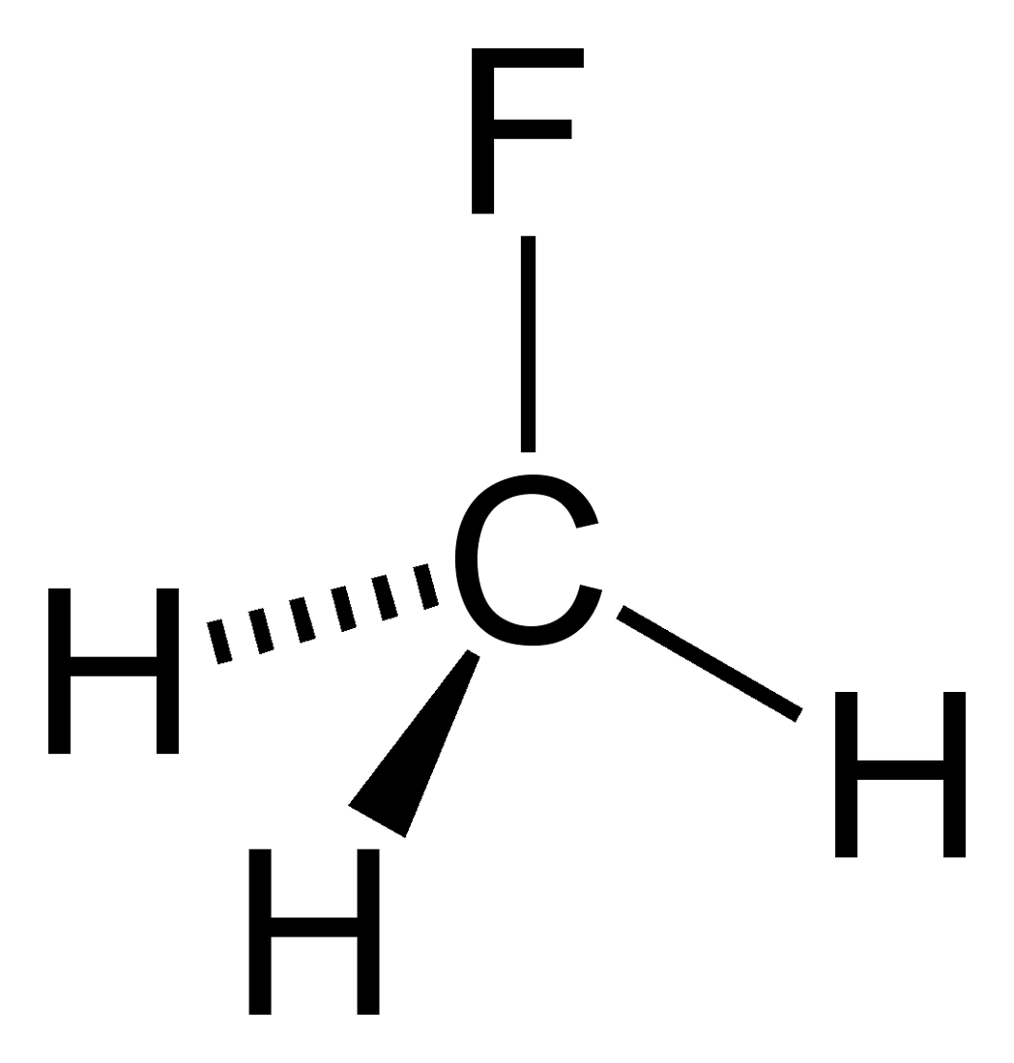

Hydrogen fluoride Methanol Fluoromethane
- all of them.

- hydrogen fluoride and methanol only.

- hydrogen fluoride only
(d) methanol only

9. Which of the following best explains why water has a lower boiling point than sodium chloride?
(a) The covalent bonds in water are weaker than the ionic bonds in sodium chloride.
(b) The intermolecular forces between water molecules are weaker than ionic bonds in sodium chloride.
(c) The molecular mass of water (18.016) is less than the molecular mass of sodium chloride (58.44).
(d) One mole of water occupies a smaller volume (18.02 mL) than one mole of sodium chloride at the same temperature and atmospheric pressure (27.01 mL).

10. The reaction between sulfur dioxide gas and oxygen gas to form sulfur trioxide gas is part of the synthesis of sulfuric acid by the Contact Process. It is catalysed by vanadium (V) oxide and after a certain time, equilibrium in the closed system is reached. Consider the following statements about the role of the catalyst in this reaction.

- The catalyst allows the reaction to reach equilibrium sooner by increasing the rate of both
the forward and reverse reactions.

(ii) The catalyst lowers the activation energy barrier for both the forward and reverse reactions.

(iii) The catalyst increases the mass of products compared to the mass of reactants when
equilibrium is reached.

Which of the following statements is correct?

- Only statement (i) above is true.

- All the above statements are true.

- None of the above statements is true.

- Only statements (i) and (ii) above are true.

11. Consider the following reaction at equilibrium:

2SO_{2(g)} + O_{2(g)} ↔ 2SO_{3(g)} ∆H = –196 kJ mol^{–1}

Which of the following would increase the rate of the reverse reaction, once equilibrium is re-established?

(i) Adding more SO₂
(ii) Adding more SO₃
(iii) Increasing the temperature
(iv) Decreasing the volume of the container

(a) (i), (ii) and (iv)

(b) (i), (iii) and (iv)

(c) (ii), (iii) and (iv)

(d) All of them

12. The following equation shows an equilibrium established in the synthesis of ammonia from its component gases:

N_{2(g)} + 3H_{2(g)} ↔ 2NH_{3(g)}

If the volume of the reaction chamber is suddenly halved (i.e. a reduction of 50%) at time T, which of the following graphs best depicts changes in the concentration of ammonia over time?
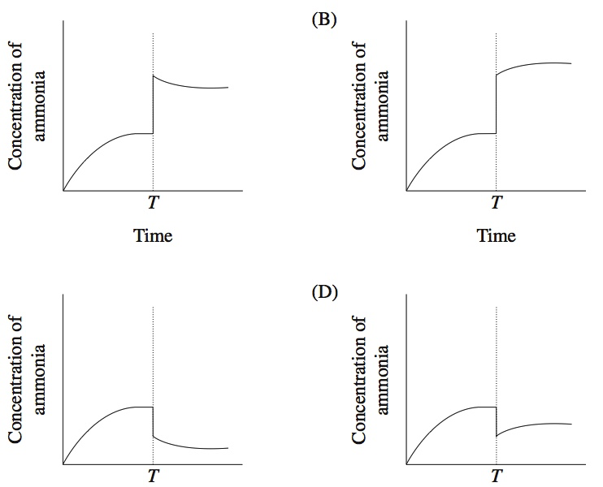
(a)
(a) (b)

(c) (d)

Questions 13, 14 and 15 refer to the following reaction between phosphorus trichloride and chlorine to form phosphorus pentachloride.

PCl_{3(g)} + Cl_{2(g)} ↔ PCl_{5(g)} ∆H = –124 kJ mol^{–1}

13. If phosphorus trichloride and chlorine were placed in a sealed and insulated container together with a catalyst, which of the following would not cause an increase in the rate at which equilibrium would be obtained?
(a) Increasing the volume of the container
(b) Increasing the state of subdivision of the catalyst
(c) Increasing the temperature
(d) All of the above

14. Which of the following statements is/are true when the system is at equilibrium?
i. Reactants are no longer turning into products
ii. The concentration of chlorine in the container stays unchanged.
iii. Adding a catalyst would not affect the proportions of the reaction mixture
- (iii) only
(b) (i) and (ii) only
(c) (ii) and (iii) only
(d) (i), (ii) and (iii)

15. Which of the following changes would not be observed once equilibrium is re-established if a little phosphorus trichloride were added at constant temperature to the equilibrium mixture above?
(a) The rate of the forward reaction would increase.
(b) The rate of the reverse reaction would increase.
(c) The concentration of phosphorus trichloride would increase.
(d) The value of the equilibrium constant (K) would decrease.

16. When chloride ions are added to a solution containing Co(H₂O)₆²⁺ the following equilibrium is established:
Co(H₂O)₆²⁺_{(aq)} + 4Cl ⁻_{(aq)} ↔ CoCl₄²⁻_{(aq)} + 6H₂O_{(l)}
Pink Blue
Solutions containing Co(H₂O)₆²⁺ and Cl ⁻ are frequently violet in colour owing to the presence of significant amounts of both Co(H₂O)₆²⁺ and CoCl₄²⁻.
Which of the following statements concerning such solutions is true?
- If the forward reaction is endothermic, cooling the solution will make the colour turn pink.

- Adding a large amount of solid sodium chloride to the solution will make the colour turn pink.

- Diluting the solution with water will make the colour turn blue.

- If the forward reaction is exothermic, heating the solution will make the colour turn blue.

17. The graph below represents the yield of an equilibrium reaction at different temperature and
pressure conditions inside a reaction vessel.
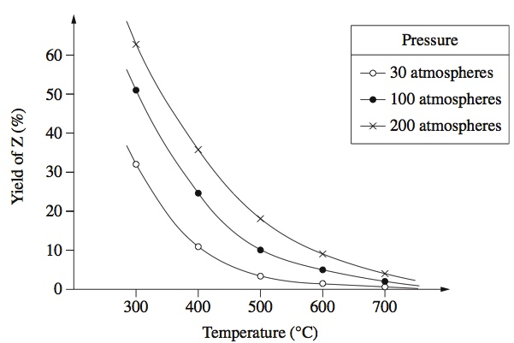

Which of the following reactions could produce the trends shown in the graph?

(a) X_{(g)} + Y_{(g)} ↔ 3Z_{(g)} ΔH = +250kJ

(b) X_{(g)} + Y_{(g)} ↔ 2Z_{(g)} ΔH = -250kJ

(c) 2X_{(g)} + 2Y_{(g)} ↔ Z_{(g)} ΔH = +250kJ

(d) 4X_{(g)} + 2Y_{(g)} ↔ 3Z_{(g)} ΔH = -250kJ

18. Consider a solution of lead (II) chloride at 25°C in equilibrium with some solid lead (II) chloride at the bottom of the solution.
Pb²⁺_{(aq)} + 2Cl ⁻_{(aq)} ↔ PbCl_{2(s)}

If the forward reaction is exothermic, which of the following is the best way to increase the concentration of the lead and chloride ions in the solution?

- Allowing some of the water to evaporate and then leaving the system to reach equilibrium again.

- Heating the system to 30°C.

- Adding some more solid lead (II) chloride.

- Sealing the container and vigorously shaking the solution.

19. Which one the following solutions has the highest concentration of dissolved ions at 25ºC?

- 0.4 molL⁻¹ CH₃COOH

- 0.3 molL⁻¹ Mg(NO₃)₂

- 0.5 molL⁻¹ Al (OH)₃

- 0.4molL⁻¹ Na₃PO₄

20. Four students were asked to test a solution for the presence of a cation by using various anions. The students obtained these results:

Student | Chloride | Sulfate | Carbonate
Acka-Dacka | No precipitate | No precipitate | Precipitate
Beeba | Precipitate | Precipitate | No precipitate
Cindy-Ella | Precipitate | Precipitate | Precipitate
Darth | No precipitate | Precipitate | No precipitate

Each student concluded that Pb²⁺ was present.

Which student had results consistent with this conclusion?

- Acka-Dacka

- Beeba

- Cindy-Ella

- Darth

21. The following sets of solutions are mixed. In which of these will there be no visible reaction?
(a) Set 1 consisting of barium hydroxide, dilute sulfuric acid, potassium nitrate.
(b) Set 2 consisting of potassium phosphate, copper(II) sulfate and sodium chloride.
(c) Set 3 consisting of sodium chloride, copper(II) sulfate and silver nitrate.
(d) Set 4 consisting of sodium iodide, barium nitrate and potassium hydroxide
22. The solubility of oxygen in seawater at 20ºC is 14.4 mgL⁻¹. Which of the following is the concentration of oxygen in seawater in molL⁻¹?
(a) 4.5 x 10⁻¹ mol L⁻¹
(b) 9.0 x 10⁻¹ mol L⁻¹

(c) 4.5 x 10⁻⁴ mol L⁻¹
(d) 9.0 x 10⁻⁴ mol L⁻¹

23. Which of the following correctly shows an acid- conjugate base pair?
HCO₃⁻_{(aq)} + H₂O_{(l)} ↔ CO₃²⁻_{(aq)} + H₃O⁺_{(aq)}
(a) HCO₃⁻ and H₃O⁺
(b) H₂O and CO₃²⁻
(c) HCO₃⁻ and CO₃²⁻
(d) All of the above

24. Which one of the following species is acting as a Lowry-Bronsted acid when ammonia gas is dissolved in a salt solution containing water and fully dissolved sodium chloride.
(a) NH₃
(b) H₂O
(c) Na⁺
(d) Cl –

25. The graph below shows the pH of a solution of a weak acid, HA, as a function of temperature.
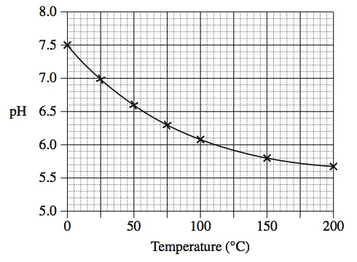
What happens as the temperature decreases?
- HA becomes less ionised and the H⁺_{(aq)} concentration increases.

- HA becomes less ionised and the H⁺_{(aq)} concentration decreases.

- HA becomes more ionised and the H⁺_{(aq)} concentration increases.
(d) HA becomes more ionised and the H⁺_{(aq)} concentration decreases.


END OF BOOKLET 1


Kira College
CHEMISTRY 12 SEMESTER 1 EXAMINATION 2015
Booklet 2

Name: __________________________ Teacher: _____________________________

For each question, shade the box to indicate your answer. Use only a blue or black pen to shade the boxes. For example, if b is your answer: a b c d
×

If you make a mistake, place a cross through that square, do not erase or use correction fluid.
Shade your new answer.

For example, if b is a mistake and d is your correct answer: a b c d

In the event that you then change your mind back to your original answer, you then cross out the second selection and then circle the first choice.
⊙
×
×

For example, if b was the first choice and d your second, but you changed your mind back
and b is your answer:
a b c d

Multiple Choice: Mark the answer by shading in the box to the LEFT of the letter you chose.

14. a b c d

15. a b c d

16. a b c d

17. a b c d

18. a b c d

19. a b c d

20. a b c d

21. a b c d

22. a b c d

23. a b c d

24. a b c d

25. a b c d

1. a b c d

2. a b c d

3. a b c d

4. a b c d

5. a b c d

6. a b c d

7. a b c d

8. a b c d

9. a b c d

10. a b c d

11. a b c d

12. a b c d

13. a b c d

Section Two: Short answer 35% (70 marks)
This section has 10 questions. Answer all questions. Write your answers in the spaces provided.
When calculating numerical answers, show your working or reasoning clearly. Express numerical answers to three (3) significant figures and include appropriate units where applicable.
Spare pages are included at the end of this booklet. They can be used for planning your responses and/or as additional space if required to continue an answer.

- Planning: If you use the spare pages for planning, indicate this clearly at the top of the page.
- Continuing an answer: If you need to use the space to continue an answer, indicate in the original answer space where the answer is continued, i.e. give the page number. Fill in the number of the question(s) that you are continuing to answer at the top of the page.

Suggested working time: 70 minutes

Question 26 (9 marks)
Complete the table below by drawing the Lewis structures of the molecules listed and either drawing or naming the shape of the molecule.

All valence shell electron pairs should be represented either as : or as — .

The first row has been completed as an example.

Molecule | Lewis diagram | Sketch or name of shape | Number of unbonded electrons in molecule
H₂O |    |   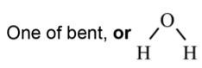 | 4 (or 2 pairs)
PH₃

CF₄

SO₃

Question 27 (4 marks)
Draw a labelled diagram of a typical ionic solid structure and use relevant knowledge of bonding and structure to explain why ionic solids tend to be non-conductors of electricity and are usually brittle.
Labelled diagram
____________________________________________________

____________________________________________________
____________________________________________________
____________________________________________________
____________________________________________________
____________________________________________________
_____________________________________________________________________________________
_____________________________________________________________________________________
_____________________________________________________________________________________

Question 28 (10 marks)

Ammonia (NH₃) and sulfur trioxide (SO₃) are two important chemicals used in a variety of industries.
(a) For each of these molecules, choose the description that best describes the polarity of the covalent bond and molecule. (2 marks)

Molecule | Polarity of covalent bonds (write polar or non-polar) | Polarity of molecule (write polar or non-polar)
NH₃

SO₃

(b) For each of the following solids, state the most dominant form of intermolecular attraction and rank them in increasing order of melting point (i.e. 1 for lowest melting point and 4 for highest melting point). (4 marks)

Solid | Name of most dominant intermolecular force in solid state | Relative melting point ranking (write 1, 2, 3 or 4)
NH₃

PH₃

AsH₃

H₂O

(c) The diagram below shows the physical attraction between neighbouring water molecules.
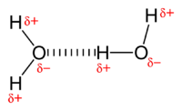

Sodium fluoride (NaF) and hydrogen fluoride are substances that are soluble in water.
i. Use the diagram above as a guide to show the most dominant form of physical attraction that exist between
- sodium fluoride and water molecules
- hydrogen fluoride and water molecules.
Your diagrams should include dotted lines (----) to show the relevant attraction as well as the location of charge densities (δ⁺ and δ⁻)
ii. Name the type of physical interaction in each case e.g. dispersion forces. (4 marks)

Sodium fluoride and water molecules | Hydrogen fluoride and water molecules
Name of most dominant attractive force | Name of most dominant attractive force

Question 29 (4 marks)
For the following reactions, describe fully the observed changes, including any:
● colour changes
● odours
● precipitates (give the colour)
● gases evolved (give the colour or describe as colourless).

(a) A sealed tube containing the equilibrium mixture, 2NO_{2(g)} ↔ N₂O_{4(g)} ΔH = -90 kJmol⁻¹ is placed in a beaker of hot water. (1 mark)
________________________________________________________________________________

(b) Barium nitrate solution is added to potassium phosphate solution. (1 mark)
________________________________________________________________________________

(c) Copper(II) chloride solid is added to sodium carbonate solution. (2 marks)
________________________________________________________________________________
________________________________________________________________________________

Question 30 (4 marks)
Write balanced ionic equations to represent the reactions described below.

(a) Sodium hydroxide solution is added to iron(III) iodide solution. (2 marks)
________________________________________________________________________________

(b) Dilute hydrochloric acid is added to potassium chromate (K₂CrO₄) solution. (2 marks)
________________________________________________________________________________

Question 31 (6 marks)
For each of the following pairs of substances, provide details of a chemical test that would allow the two substances to be distinguished from one another. Equations are not required.
Substances | Chemical test | Observations
Na₂SO_{4(s)}  and  NaCH₃COO_{(s)} |  | with Na₂SO_{4(s)} :  with NaCH₃COO_{(s)} :
KOH_{(aq)}  and  K₃PO_{4(aq)} |  | with KOH_{(aq)} :  with K₃PO_{4(aq)} :

Question 32 (10 marks)
Phosphine (PH₃) is a gas that can be produced by bubbling hydrogen gas through molten phosphorus. The reaction is reversible
P_{4(l)} + 6H_{2(g)} ↔ 4PH_{3(g)} + 33 kJ

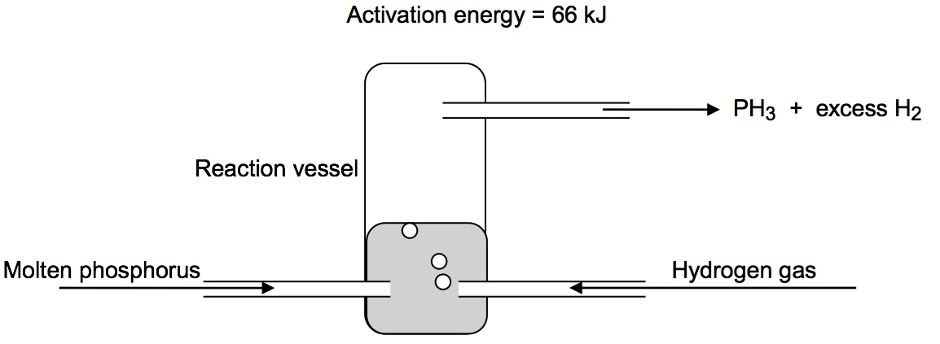
(a) Use the axes below to draw a labelled energy profile diagram to represent the process. State clearly the axes’ headings, reactants, products, activation energy and change in enthalpy (ΔH). (4 marks)

(b) Would a high temperature, or a low temperature, most likely be used in this industrial process?
(Circle one response below). (3 marks)

Moderate Temperature Low Temperature

State the effect of temperature on the forward reaction rate and yield of this industrial process.

 | High Temperature | Low Temperature
Effect on forward reaction rate
(write increase, decrease or no change)

Effect on yield
(write increase, decrease or no change)

(c) Mixtures of ammonia and phosphine can be separated by distillation due to their different boiling points. Explain why the boiling point of phosphine is lower than that of ammonia even though its molar mass is nearly twice that of ammonia. (3 marks)

 | Phosphine (PH₃) | Ammonia (NH₃)
Boiling point (ºC) | - 88 | - 33
Molar mass (gmol⁻¹) | 33.99 | 17.03

________________________________________________________________________________

________________________________________________________________________________

________________________________________________________________________________

________________________________________________________________________________

________________________________________________________________________________

________________________________________________________________________________

________________________________________________________________________________

________________________________________________________________________________

________________________________________________________________________________

________________________________________________________________________________

Question 33 (8 marks)
Consider the equilibrium reaction below
CO_{(g)} + 2H_{2(g)} ↔ CH₃OH_{(g)} ΔH = -90 kJmol⁻¹

Indicate in the table below whether there would be an increase, decrease, or no change in the concentration of CO_{(g)} after the changes given in the table are imposed on the system and equilibrium has been re-established. Provide a brief explanation for the observation using relevant knowledge of reaction rates and Collision Theory.

Change | Change in concentration of CO_{(g)} (circle the correct response) | Brief explanation
The volume of the reaction vessel is halved | . increase  . decrease  . no change
The temperature of the reaction system is doubled | . increase  . decrease  . no change
Neon gas (Ne) is pumped into the system while keeping the volume constant | . increase  . decrease  . no change
H₂ gas is pumped into the system while keeping the volume constant | . increase  . decrease  . no change

Question 34 (5 marks)
A number of ions can act as an acid or a base in certain conditions. These ions are said to be amphiprotic in nature.
(a) Hydrogenphosphate (HPO₄²⁻) is a polyatomic ion that can act as an acid or a base. Use a suitable chemical equation to show that HPO₄²⁻ can act as (2 marks)
i. a Lowry-Bronsted acid
________________________________________________________________________________

ii. a Lowry-Bronsted base
________________________________________________________________________________

(b) The equilibrium constant (K) for the forward reaction of the equilibrium system below is 1.0 x 10⁻² at room temperature.
HSO₄⁻_{(aq)} ↔ H⁺_{(aq)} + SO₄²⁻_{(aq)}
Is HSO₄⁻ a strong or weak acid at room temperature? Circle one response below. (1 mark)
Strong acid Weak acid

Explain your answer using relevant knowledge of acids and bases theories and equilibrium constant. (2 marks) ________________________________________________________________________________
________________________________________________________________________________
________________________________________________________________________________
________________________________________________________________________________
________________________________________________________________________________

Question 35 (10 marks)
In a Science experiment, a student measures the conductivity (in milliAmps) of three solutions of ethanoic acid. The diagram below shows her experimental set up.
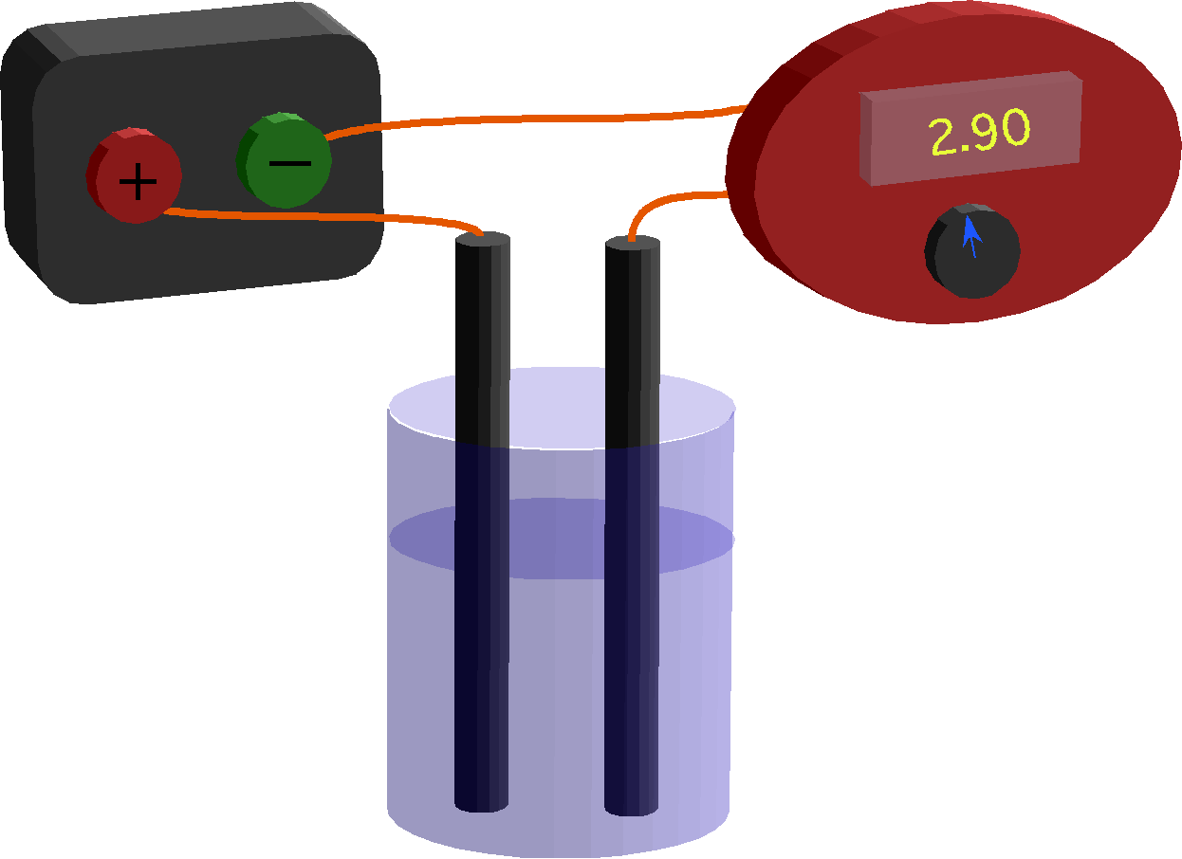

The students’ results are listed in the table below

Solution | pH | Electrical current reading (milliAmps)
1 | 2 | 20
2 | 3 | 9
3 | 4 | 4
- State the relationship between pH and electrical conducting ability of ethanoic acid for this experiment. (1 mark)
_____________________________________________________________________________________
_____________________________________________________________________________________

- Explain the relationship stated in part (a) using relevant knowledge of solutions and theories of acids and bases. (2 marks)
_____________________________________________________________________________________
_____________________________________________________________________________________
_____________________________________________________________________________________
_____________________________________________________________________________________
_____________________________________________________________________________________
_____________________________________________________________________________________
_____________________________________________________________________________________
_____________________________________________________________________________________

- Would you expect a 0.1 molL⁻¹ solution of hydrochloric acid to have the same conductivity as that of a 0.1 molL⁻¹ solution of ethanoic acid? Explain your answer using relevant knowledge of the theories of acids and bases. (3 marks)
_____________________________________________________________________________________
_____________________________________________________________________________________
_____________________________________________________________________________________
_____________________________________________________________________________________
_____________________________________________________________________________________
_____________________________________________________________________________________
_____________________________________________________________________________________
_____________________________________________________________________________________
_____________________________________________________________________________________
_____________________________________________________________________________________
_____________________________________________________________________________________

(d) Phosphoric acid (H₃PO₄) is a weak triprotic acid.
List all the ions present (in order of decreasing concentration) in a 0.1 molL⁻¹ solution of phosphoric acid. Explanation is not required. (2 marks)
_____________________________________________________________________________________
_____________________________________________________________________________________
_____________________________________________________________________________________
_____________________________________________________________________________________

(e) 900.0 mL of water is added to a 100.0 mL solution of a strong acid solution that has a pH of 6. Calculate the pH of the new solution. (2 marks)

Section Three: Extended Answers 40% (80 marks)
This section contains four (4) questions. You must answer all questions. Write your answers in the spaces provided.
Where questions require an explanation and/or description, marks are awarded for the relevant chemical content and also for coherence and clarity of expression. Lists or dot points are unlikely to gain full marks.
Final answers to calculations should be expressed to three significant figures.
Spare pages are included at the end of this booklet. They can be used for planning your responses and/or as additional space if required to continue an answer.

● Planning: If you use the spare pages for planning, indicate this clearly at the top of the page.
● Continuing an answer: If you need to use the space to continue an answer, indicate in the original answer space where the answer is continued, i.e. give the page number. Fill in the number of the question that you are continuing to answer at the top of the page.
Suggested working time: 80 minutes.
_____________________________________________________________________________________

This space intentionally left blank

Question 36 (10 marks)

The preparation of sulfuric acid (H₂SO₄) from iron pyrites (FeS₂) can be represented by the following series of reactions:

4FeS₂ + 11O₂ → 2Fe₂O₃ + 8SO₂
2SO₂ + O₂ → 2SO₃ (Contact Process)
SO₃ + H₂O → H₂SO₄

(a) How many moles of sulfuric acid would be produced from ONE mole of iron pyrites? (1 mark)

(b) What mass of iron pyrites would be needed to produce 123 tonne (1 tonne = 1 x 10⁶ g) of sulfuric acid if the Contact process only converts 95.0% of the sulfur dioxide and the other reactions achieve 100% conversion? (6 marks)

Sulfurous acid (H₂SO₃) can be produced by the dissolving of sulfur dioxide gas in liquid water under the
right conditions.

SO_{2(g)} + H₂O_{(l)} → H₂SO_{3(aq)} (Reaction 1)

H₂SO₃ is a weak acid that partially ionises to form hydrogen and hydrogen sulfite ions.

H₂SO_{3(aq)} → H⁺_{(aq)} + HSO₃⁻_{(aq)}

(c) If Reaction 1 above is slightly exothermic then predict the effect of the following changes on the pH of the solution (3 marks)

Change to equilibrium | Effect on pH  (write increase, decrease or no change)
A little concentrated nitric acid is added

Finely powdered NaOH_{(s)} is added

The temperature of the system is increased to a new constant value

Question 37 (20 marks)
Magnesium, a reactive metal found in many common minerals, is also an essential nutrient for both plants and animals.
(a) Write the electron configuration for magnesium ion (Mg²⁺) . (1 mark)
________________________________________________________________________________

(b) Draw the Lewis electron dot diagram for MgCl₂ (1 mark)

(c) Successive ionization energies of magnesium are given in the table below

 | ^{First} | ^{Second} | ^{Third}
Energy required / kJmol⁻¹ | 738 | 1450 | 7730
Explain why the third ionization energy is much greater than the second ionisation energy. (3 marks)
________________________________________________________________________________
________________________________________________________________________________
________________________________________________________________________________
________________________________________________________________________________
________________________________________________________________________________
________________________________________________________________________________

(d) Magnesium metal is often used in school laboratories to make hydrogen gas. The equation for the reaction between dilute sulfuric acid and magnesium metal is

Mg_{(s)} + 2H⁺_{(aq)} → Mg²⁺_{(aq)} + H_{2(g)}
In a reaction rate experiment, a student studies the rate of the reaction above by measuring the volume of hydrogen gas produced over time. Assuming no significant errors are made, sketch a graph to show what the student is most likely to observe from the volume readings over time. (1 mark)

Volume
of
hydrogen gas

Time

(e) A well known compound of magnesium is magnesium hydroxide Mg(OH)₂ which is commonly used as an antacid to neutralise stomach acid.

A typical magnesium hydroxide antacid tablet contains 300mg of magnesium hydroxide.

In the stomach, the normal concentration of hydrochloric acid is 0.100 molL⁻¹. The volume of acid in the stomach can be assumed to be 0.650 litres. Calculate the number of moles of hydrochloric acid in the stomach. (1 mark)

A stressed-out student, studying for her Chemistry exam eats a whole packet of Tim Tams, causing the concentration of the acid in her stomach to rise to 0.200 molL⁻¹. Calculate the number of moles of hydrochloric acid at this new concentration. (1 mark)

Calculate the number of magnesium hydroxide tablets the student would need to reduce the concentration of acid in her stomach back to the normal level. The non-ionic chemical reaction between stomach acid and magnesium hydroxide is:
2HCl _{(aq)} + Mg(OH)_{2(s)} → MgCl_{2(aq)} + 2H₂O_{(l )} (4 marks)

(g) Magnesium hydroxide is only sparingly soluble in water and the equilibrium below exists in a saturated solution.
Mg²⁺_{(aq)} + 2OH⁻_{(aq)} → Mg(OH)_{2(s)}
Use relevant knowledge of reaction rates and Collision Theory to state and explain how changes in pH affect the solubility of solid magnesium hydroxide (i.e. more soluble or less soluble) in the equilibrium system above if the temperature is kept constant. (8 marks)

Change: Increase in pH

Solubility of Mg(OH)₂: more soluble less soluble (circle one response)
Explanation: _____________________________________________________________________
_______________________________________________________________________________
_______________________________________________________________________________
______________________________________________________________________________
_______________________________________________________________________________
______________________________________________________________________________
_______________________________________________________________________________

Change: Decrease in pH

Solubility of Mg(OH)₂: more soluble less soluble (circle one response)
Explanation: _____________________________________________________________________
_______________________________________________________________________________
_______________________________________________________________________________
______________________________________________________________________________
_______________________________________________________________________________
______________________________________________________________________________
_______________________________________________________________________________

Question 38 (25 marks)
A group of students investigated the rate of reaction between aqueous sodium thiosulfate (Na₂S₂O₃) and hydrochloric acid according to the non-ionic chemical equation below.
Na₂S₂O_{3(aq)} + 2HCl _{(aq)} → 2NaCl _{(aq)} + SO_{2(g)} + S_{(s)} + H₂O_{(l)}
The two reagents were rapidly mixed and placed over a mark on a piece of paper. The time taken for the precipitate of sulfur to obscure the mark ‘X’ (i.e. ‘X’ can no longer be seen) when viewed through the reaction mixture was recorded.
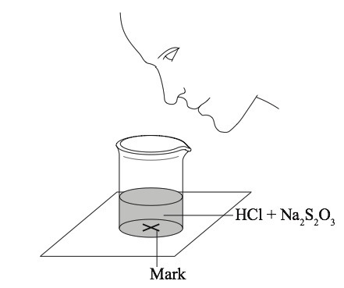

Initially the students measured out 10.0 mL of 0.500 molL⁻¹ hydrochloric acid and to this solution added 40.0 mL of 0.0200 molL⁻¹ aqueous sodium thiosulfate. The mark on the paper was obscured 47 seconds after the solution was mixed.

(a) The teacher asked the students to study the effect of halving the concentration of sodium
thiosulfate on the rate of the reaction.

i. State the volumes of the liquids that should be mixed. (2 marks)

Liquid | 0.500 molL⁻¹ HCl | 0.0200 molL⁻¹ Na₂S₂O₃ | Water
Volume

ii. State why it is important that the students use a similar beaker for both occasions. (1 mark)

_______________________________________________________________________________

iii. State one (1) safety aspect that was neglected by the instructional diagram above. (1 mark)

_______________________________________________________________________________

iv. The results of a separate experiment investigating the effect of the concentration of hydrochloric
acid of the reaction rate, while keeping the concentration of the sodium thiosulfate at the original
concentration value, are given in the table below.

Concentration of HCl (molL⁻¹) | 0.020 | 0.040 | 0.060 | 0.080
Time (s) | 89.1 | 72.8 | 62.4 | 54.2
On the axes provided, draw a fully labelled graph to plot the information above. (4 marks)

v. Explain the shape of the graph using relevant knowledge of Collision theory and reaction rates. (2 marks)
_____________________________________________________________________

_____________________________________________________________________________

_____________________________________________________________________________

_____________________________________________________________________________

(b) The teacher asked the students to devise another technique to measure the rate of this reaction. One group suggested recording how long it takes for the pH of the solution to change by one unit.

Which of the following graphs best represents the change in the pH of the reaction mixture as the experiment proceeds? (Circle one of the graphs below) (1 mark)

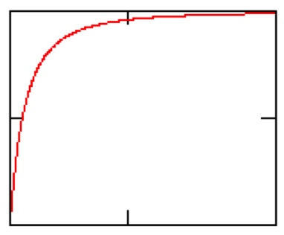
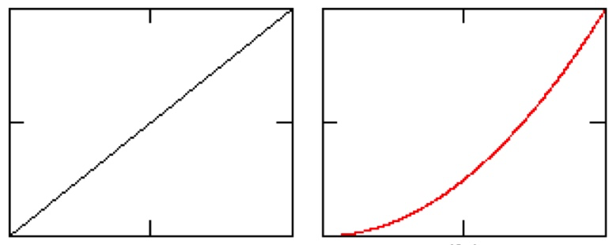

Graph A Graph B Graph C

(c) Another group of students suggested measuring the sulfur dioxide gas evolved over time.

i. Calculate the volume of sulfur dioxide gas (in litres) that a mixture of 10.0 mL of 0.500 molL⁻¹ hydrochloric acid and 40.0 mL of 0.0200 molL⁻¹ aqueous sodium thiosulfate would produce at 101.3 kPa and 25ºC. Write your final numerical answer in 3 significant figures. (5 marks)

ii. Sulfur dioxide gas, a major cause of acid rain, is highly soluble in water. Use your knowledge of
relevant bonding theories to explain why this is the case. You may find a suitable diagram useful
in your explanation. (2 marks)

_____________________________________________________________________________

_____________________________________________________________________________

_____________________________________________________________________________

_____________________________________________________________________________

_____________________________________________________________________________

_____________________________________________________________________________

_____________________________________________________________________________

iii. The equilibrium equation for the dissolution of sulfur dioxide in water is shown below.

SO_{2(g)} + H₂O_{(l)} ↔ HSO₃⁻_{(aq)} + H⁺_{(aq)}

Write an equilibrium expression, K for the reaction above. (1 mark)

K ₌

At 0ºC, the solubility of sulfur dioxide in water is 228 gL⁻¹ but at a temperature of 90ºC, its solubility in water is only 5.8 gL⁻¹. Is the dissolution of sulfur dioxide in water endothermic or exothermic? Explain your answer using relevant knowledge of Collision theory and reaction rates (4 marks)
_____________________________________________________________________________
_____________________________________________________________________________
_____________________________________________________________________________
_____________________________________________________________________________
_____________________________________________________________________________
_____________________________________________________________________________
_____________________________________________________________________________
_____________________________________________________________________________
_____________________________________________________________________________

iv. Sulfur dioxide can form two different acids in water, sulfurous acid (H₂SO₃) and sulfuric acid (H₂SO₄). The ionisation equation and the K value for each acid at 25ºC is shown below.
H₂SO_{3(aq)} → H⁺_{(aq)} + HSO₃⁻_{(aq)} K = 1.3 x 10⁻²
H₂SO_{4(aq)} → H⁺_{(aq)} + HSO₄⁻_{(aq)} K = 1.0 x 10³
Which of the two acids above is a better electrolyte at 25ºC? Explanation is not required. (1 mark)
_____________________________________________________________________________

Write a chemical equation to show that HSO₃⁻ can act as an Arrhenius acid. (1 mark)
_____________________________________________________________________________

Question 39 (25 marks)

Mildews and fungi can cause great damage to grape vines. One chemical spray used to control these diseases is called Bordeaux mixture. A home gardener who wishes to treat his grapes with Bordeaux mixture prepares a mixture using the instructions given below.

i. Add 25.0 g of calcium hydroxide powder to 25.0 g of CuSO₄.5H₂O powder.
ii. Mix these powders with a small amount of water to make a paste.
iii. Add the paste to 5.00 L of water and mix well.
iv. Use the mixture immediately after preparation.

The non-ionic equation for the reaction that occurs after the powders are mixed with water is

Ca(OH)_{2(aq)} + CuSO_{4(aq)} → CaSO_{4(aq)} + Cu(OH)_{2(s)}

(a) Determine the limiting reactant for the above reaction. Show all working. (4 marks)

(b) Calculate the unused mass of the excess reactant. (3 marks)

(c) What colour (if any) will the precipitate have? ___________________________ (1 mark)

Commercially, elemental sulfur (S) can be used to control outbreaks of powdery mildew on grapes.

(d) Write the electron configuration for sulfide ion? _____________________________ (1 mark)

(e) Which of the following species would you expect to have a larger radius? (Circle one of the answers below).

A SULFUR ATOM A SULFIDE ION (1 mark)

(f) Explain your answer to part (e) using relevant knowledge of atomic structure and bonding. (3 marks)

____________________________________________________________________________

____________________________________________________________________________

____________________________________________________________________________

____________________________________________________________________________

____________________________________________________________________________

____________________________________________________________________________

Sulfur remaining on the grapes after harvest can be converted to a number of undesirable compounds during fermentation in wine production.

A wine chemist uses a method called Atomic Absorption Spectroscopy (AAS) to determine the amount of sulfur remaining on grapes.

In a particular analysis, 100.0 g of grapes are treated with 100.0 mL of surfactant solution to absorb the sulfur remaining on the grapes when they were harvested.

25.00 mL of this surfactant solution is then treated to convert all of the sulfur to sulfate ions and then dried to produce a powder containing the sulfate ions.

This powder is transferred to a flask containing 2.00 mL of 200 mgL⁻¹ solution of barium Ba²⁺ ions.

The volume of solution in the flask is then made up to 10mL. A precipitate of BaSO₄ forms and settles to the bottom of the flask.

A calibration curve was prepared using standard solutions of 10, 20, 30 and 40 mgL⁻¹ Ba²⁺_{(aq).}
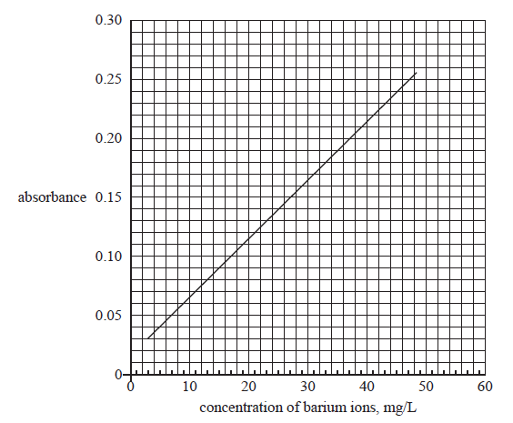

(g) A small amount of the solution containing the unreacted Ba²⁺ ions is removed from the flask and analysed using atomic absorption spectroscopy (AAS). This solution gave an absorbance reading of 0.11.

Use the graph above to determine the concentration of barium ions remaining per 1 L of solution. Hence determine the mass of barium ions, in mg, remaining in the 10.00 mL sample solution.
(2 marks)

(h) Determine the amount of barium ions, in moles, in the original 2.00 mL of 200 mgL⁻¹ solution of Ba²⁺ provided and use this value to calculate the amount of barium, in moles, that reacted to produce the barium sulfate precipitate. (3 marks)

(i) Determine the mass of sulfur, in mg, remaining on the 100 g of harvested grapes. (4 marks)

One common home remedy for the treatment of mildews involves the use of ‘bicarbonate of soda’
(potassium or sodium hydrogencarbonate). It is believed that the spraying of this solution makes plant
leaves alkaline and thus prevents the germination of mildews’ spores.

(j) Write the chemical formula for the conjugate base of hydrogencarbonate ion. ___________ (1 mark)

(k) In a field study, solutions containing 5000 – 10000 ppm of NaHCO₃ were found to be the most effective in controlling mildews growth in but solutions containing over 20000 ppm NaHCO₃ were found to damage and/or severely affect leaf growth in ornamental plants.

Calculate the mass of NaHCO₃ (in grams) required to make 100.0 mL of NaHCO₃ solution with a concentration of 10000 ppm assuming that NaHCO₃ dissolves completely in water and the density of water is 1.0 gmL⁻¹. (2 marks)


END OF EXAM
Spare answer page

Question number: ___________________

Spare answer page

Question number: ___________________

Spare answer page

Question number: ___________________

